Paper Review:
Fine-Particulate Air Pollution
and Life Expectancy in the United States
C. Arden Pope III, Ph.D., Majid Ezzati, Ph.D., and Douglas W. Dockery, Sc.D.
Valmik Khadke
April 28, 2009
Many recent studies have been trying to find the association between long-term exposure to fine particulate matter and mortality. All support the view that relatively prompt and sustained health benefits are derived from improved air quality. Therefore this paper is geared towards answering the fundamental question “Do improvements in air quality result in measurable improvements in human health and longevity?”
In late 70s and early 80s U.S. Environmental Protection Agency (EPA) had installed dichotomous samplers to measure the inhalable particles in the air for research purpose. They were measuring fine particulate matter, which is a mixture of solid particles and liquid droplets such as aerosols, smoke fumes, ash, pollen and etc. This data was used for the research purpose by American Cancer Society. After 1983, no broad-based monitoring network systematically and routinely collected data until required by National Ambient Air Quality Standard in 1997. For this study the authors looked at two 5 year periods, period 1: (1978-1983), period 2: (1997-2001). Originally we had data for 116 metropolitan areas, but the matching data for both periods was available for only 51 metropolitan areas. Therefore the authors used that for the analysis (51 metropolitan areas are shown on the next page)
Authors also collected data from U.S. Census bureau for information on county-level socioeconomic and demographic variables such as population, income, number of high-school graduates, race and etc. They believe that this factors might play an effect in life expectancy, such as if we looked at a expensive neighborhood, then it might be less populated, better diet, less signs of criminal activity, and might have something to do with better air quality. Authors also collected data on lung cancer and Chronic Obstructive pulmonary disease (COPD), because they will indicate the population’s cumulative exposure to smoking. They also compared the national mortality statistics, and identified the number of deaths related to smoking for both periods. Formal Hypothesis proposed by the authors: We hypothesize that metropolitan areas with the largest declines in fine-particulate pollution would have the largest increases in life expectancy even after adjustment for changes in various socioeconomic and demographic characteristics and proxy variables for status with regard to smoking.
At first authors ran a simple regression model (Life Expectency~PM_{2.5}) for both periods and acquired the following graphs.
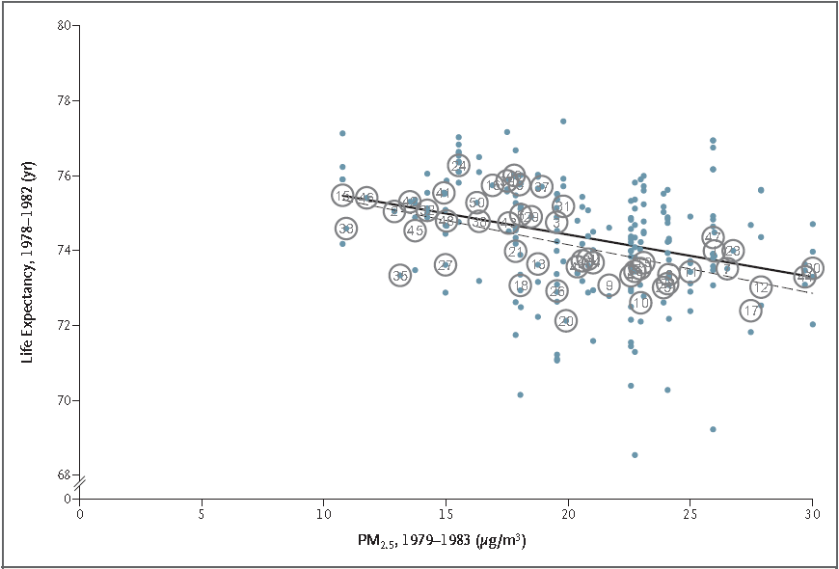Period 1 (1979-1983)
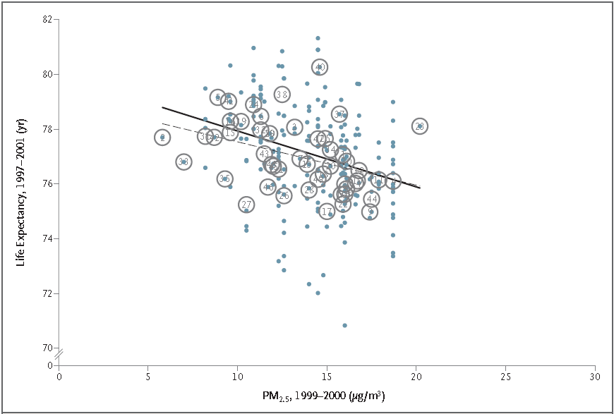Period 2 (1999-2000)
Not a strong correlation, because there is substantial variation, or scatter, around the regression line, indicating that there are other important factors that influence the life expectancy. Therefore they revised their simple model, and introduced various socioeconomic, demographic variables, and proxy indicators for smoking. They performed stepwise regression, and noticed that reductions in PM2.5 generally entered the model after changes in per capita income and proxy indicators for prevalence of smoking were introduced. Authors presented a table of seven models they ran, but only mentioned Model 4, and Model 7 in their conclusion. Following is the table that was presented to show seven models the authors looked at: 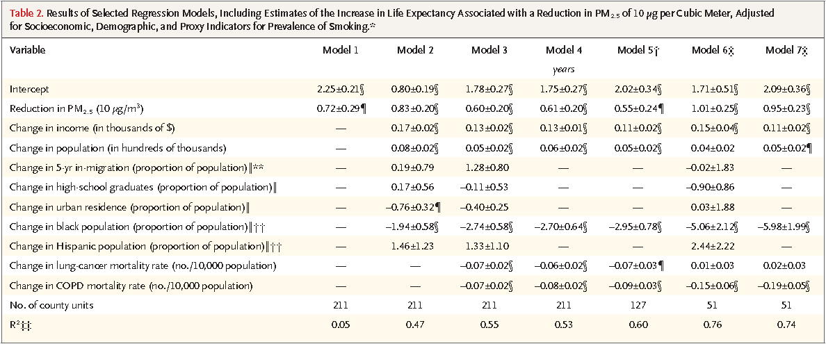
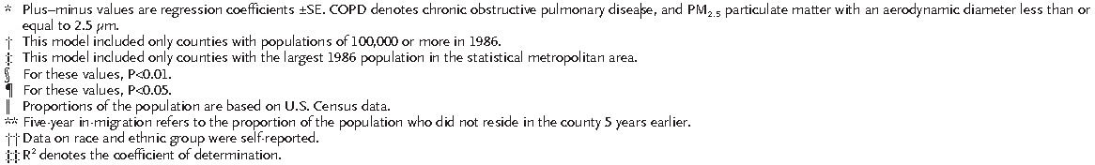
Model 1 was the simple model. Model 3 was the full model at the county-level, and Model 4 contains only the factors that were deemed significant from model 3. Also Model 6 was the full model at the county level (that contains only the counties with largest populations), and Model 7 contains only the factors that were deemed significant from model 6.We can see that R² definitely improved when looking at the counties with the largest populations (Model 6 and Model 7). Over all in conclusion a decrease of 10 μg per cubic meter in the fine-particulate concentration was associated with an estimated increase in life expectancy of approximately 0.61±0.20 year. Also for the approximate period of 1980 through 2000, the average increase in life expectancy was 2.72 years for the counties. Authors ended the paper with few discussions points such as; it would have been informative if pollution had actually increased in some of the areas that were initially less polluted. However, pollution did not increase in any of the metropolitan areas. They also performed weighted regression, but achieved similar results. One important issue I would like to bring up as a reader was that authors never discussed any tryouts of interactions. Interaction such as race versus income might play a better factor in life expectancy and so on. Overall this is a fairly low mathematical aspect, and very easy to read.

